**DAILY ONLINE ACTIVITIES SUMMARY**

|  |  |  |  |  |  |  |
| --- | --- | --- | --- | --- | --- | --- |
| **Date:** | | | **31/05/2020** | **Name:** | **JASLINE SHARON TAURO** | |
| **Sem & Sec** | | | **4th sem, A Section** | **USN:** | **4AL18CS029** | |
| **Online Test Summary** | | | | | | |
| **Subject** | **N/A** | | | | | |
| **Max. Marks** | **N/A** | | | **Score** | **N/A** | |
| **Certification Course Summary** | | | | | | |
| **Course** | | | **Trailhead Basics** | | | |
| **Certificate Provider** | | **SALES FORCE** | | **Duration:** | | **3 HRS** |
| **Coding Challenges** | | | | | | |
| Problem Statement:Write a Java program to calculate nPr. | | | | | | |
| **Status: DONE** | | | | | | |
| **Uploaded the report in GitHub** | | | | **YES** | | |
| **If yes Repository name** | | | | <https://github.com/jaslinesharontauro/JAVA_Prgms> | | |
| **Uploaded the report in slack** | | | | **YES** | | |

**Online Test Details: (Attach the snapshot and briefly write the report for the same)**

**Certification Course Details: (Attach the snapshot and briefly write the report for the same)**

**Coding Challenges Details: (Attach the snapshot and briefly write the report for the same)**

**CERTIFICATION COURSE DETAILS**

**Today I have done certification course on TRAILHEAD BASICS. I learnt about the Picklist Administration. I also learnt how to create custom objects in My Trailhead Playground. I completed this particular module as well as Data Modelling concepts.**



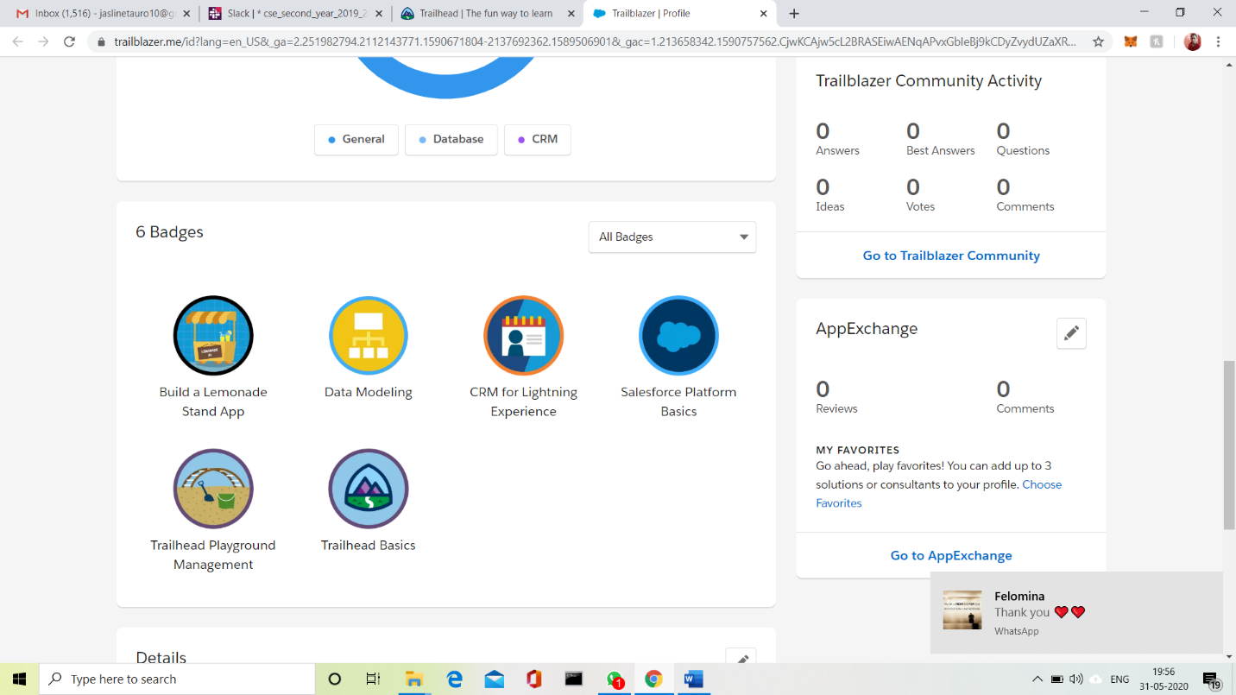

**CODING CHALLENGES DETAILS:**

**Problem statement:**

## Write a Java program to calculate nPr.

**nPr** represents n permutation r and value of nPr is **(n!) / (n-r)!**

**Input:**  
The first line of the input contains **T** denoting the number of testcases. T testcases follow. First line of the test case will be the value of n and r respectively.

Output:  
For each test case, in a new line, output will be the value of nPr.

Constraints:  
**1 <= T <= 100  
1 <= n, r <= 20  
n >= r**

**Example:**  
Input:  
2  
2 1  
10 4  
Output:  
2  
5040



 